Tab 1



Mtel (Thailand) Co., Ltd.

For

T.C.C. Technology Co., Ltd.

One Bangkok Mobile Application
Invitation Code & Upgrade Membership
Technical Design Document
To
T.C.C. Technology Co., Ltd.

Total 25 sheets (w/h cover sheet)
 | PROJECT NAME | JOB NO. | DOCUMENT NO. | REV.
 | One Bangkok Mobile Application - Invitation Code & Upgrade Membership Technical Design Document |  |  | 01

Content table
1. Document Purpose 4
2. Project Background & Overview 5
3. Goals & Non-Goals 6
3.1. Goals 6
3.2. Non-Goals 6
4. System Architecture 7
4.1. Architectural Overview 7
4.2. Component Architecture 7
4.2.1. Controller Layer 7
4.2.2. Service Layer 7
4.2.3. Repository Layer 8
4.2.4. External Integration Layer 8
4.2.5. Database Layer 8
4.2.6. Cache Layer 9
5. Functional Design 9
5.1. Invitation Code 9
5.1.1. Login with Invitation Code 9
5.1.2. Disable Name Editing for Invited User 12
5.1.3. Generate Invitation Codes 13
5.2. Upgrade Membership 13
5.2.1. Upgrade Membership with Code 13
5.2.2. Generate Invitation Codes 15
6. Data Flow 16
6.1. Invitation Code 16
6.1.1. Registration with invitation-code Flow 16
6.1.2. Table ER - Diagram 17
6.1.3. Generate Invitation Code Flow 18
6.2. Upgrade Membership 19
6.2.1. Upgrade Membership Flow 19
6.2.2. Generate Code Upgrade Flow 20
7. Example Request/Response 21
7.1. Request - Invitation Code Registration 21
7.1.1. Response (Success - 200) 22
7.1.2. Response (Error - 400 - Invalid Code Format) 22
7.1.3. Response (Error - 404 - Code Not Found) 22
7.1.4. Response (Error - 409 - Duplicate Identity) 22
7.1.5. Response (Error - 500 - SSO Registration Failed) 22
7.1.6. Error Scenarios 23
7.1.7. HTTP Status Codes 23
7.2. Request - Generate Invitation code 23
7.2.1. Response (Success - 200) 24
7.2.2. Response (Error - 500) 24
7.2.3. Error Scenarios 24
7.3. Request - Upgrade Membership 24
7.3.1. Response (Success - 200) 24
7.3.2. Error Scenarios 25
7.4. Request - Generate Upgrade Membership code 25
7.4.1. Response (Success) 25
7.4.2. Response (Error) 25

One Bangkok Mobile Application - Invitation Code and Upgrade Membership
To
T.C.C. Technology Co., Ltd.
This document serves as the official Technical Design Document (TDD) for the implementation of the Invitation Code and Upgrade Membership features within the One Bangkok Application, leveraging the Single Sign-On (SSO) platform as the primary source of truth. The initiative formalizes the migration of code generation, validation, and user identity management from the existing BZB web-based implementation to a fully native in-app experience integrated with SSO.
The primary objective is to establish a secure, centralized, and scalable architecture for managing invitation and upgrade membership codes while improving user experience and operational efficiency. By storing and validating codes within SSO, the solution ensures consistent identity handling, accurate tier assignment, and reliable synchronization with downstream systems.
This document describes the proposed architecture, functional design, technical approach, and delivery responsibilities to align all stakeholders at T.C.C. Technology Co., Ltd. and to support the successful implementation and deployment of the solution.

Document Purpose
The purpose of this Technical Design Document (TDD) is to define the technical architecture, system interactions, data structures, and implementation approach for the Invitation Code and Upgrade Membership features in the One Bangkok Application.
This document provides detailed guidance on how these features will be designed and implemented using the Single Sign-On (SSO) platform as the primary source of truth for code generation, validation, user identity management, and tier assignment. It serves as a reference for development, quality assurance, security review, and operations teams to ensure consistent understanding and execution.
Additionally, this TDD establishes design principles, technical assumptions, dependencies, and constraints, enabling stakeholders to assess feasibility, identify risks, and align on implementation standards prior to development.
The document is intended to support successful delivery of a secure, scalable, and maintainable solution that meets business requirements and enhances overall user experience.

Project Background & Overview
Currently, the Invitation Code and Upgrade Membership functionalities are operated through a BZB web-based implementation, where code generation, validation, and tier assignment are managed outside of the One Bangkok Application and Single Sign-On (SSO) ecosystem. This architecture introduces dependency on external systems, limited visibility into user identity states, and inconsistent synchronization of membership tiers across platforms.
With the One Bangkok Application now fully integrated with the SSO platform, SSO has become the primary source of truth for user authentication, identity attributes, and persona management. To align with this architecture, the Invitation Code and Upgrade Membership features will be migrated to leverage SSO for code storage, validation, and user-tier mapping.
This initiative aims to transition both features into a native in-app experience, replacing BZB webview flows with SSO-integrated services and application user interfaces. The target solution provides centralized management of codes, consistent identity handling, and reliable tier assignment, while improving user experience, security, and operational efficiency.
At a high level, the solution consists of:
- SSO services for generating, storing, and validating Invitation Codes and Upgrade Membership Codes
- Mobile application UI flows for code entry and verification
- Backend integration between SSO and downstream systems to synchronize tier and role updates

Goals & Non-Goals

Goals
The goals of this technical design are to:
- Establish Single Sign-On (SSO) as the primary source of truth for Invitation Codes and Upgrade Membership Codes, including generation, storage, validation, and status management.
- Enable secure and scalable validation of codes through SSO services.
- Support native in-app user flows for Invitation Code login and Upgrade Membership code entry without relying on external webview solutions.
- Ensure consistent assignment and update of user tiers (Influencer, Ambassador) and personas based on code configuration.
- Improve reliability of identity data and synchronization between SSO and downstream systems.
- Provide a foundation that supports future expansion of code-based campaigns or membership upgrade mechanisms.
- Maintain compatibility with existing authentication, verification (email/phone), and password setup flows.

Non-Goals
The following items are explicitly out of scope for this design:
- Redesign of the overall SSO authentication architecture.
- Changes to existing business rules for tier benefits, privileges, or reward calculation.
- Migration or remediation of historical codes generated by BZB.
- Implementation of admin or back-office UI for code generation (codes will be generated via API / tools such as Postman as part of this phase).
- Modifications to existing email or SMS verification mechanisms.
- Changes to campaign notification logic outside of triggering based on successful code application.

System Architecture

Architectural Overview
The Invitation Code and Upgrade Membership features are implemented within the IAM service using a layered architecture pattern:
- Controller Layer – Handles HTTP request/response
- Service Layer – Contains business logic and orchestration
- Repository Layer – Handles database operations
- External Integration Layer – Handles communication with BZB
- Database Layer – Stores code and activation records
- Cache Layer – Stores user card information (BZB cache)
IAM acts as the orchestration layer and enforces validation, state management, and transaction consistency.

Component Architecture

Controller Layer
- File: src/controllers/retail_code_controller.ts
- Responsibilities:
  - Validate required headers (x-account-id, x-access-token)
  - Validate request body (code)
  - Map service response to HTTP response
  - Standardize error handling
- Endpoints:
  - POST /retail-code/upgrade-membership
  - POST /retail-code/generate-code/upgrade-member-codes

Service Layer
- File: src/services/retail_code_service/index.ts
- Key Method:
  - activateUpgradeMemberCode
  - createMemberCodes
- Responsibilities:
  - For Upgrade Membership:
    - Validate retail code (existence, expiry, activation status)
    - Retrieve profile by account_id
    - Validate profile.sso_id
    - Call BZB external API (user/register_invite)
    - Update code activation record
    - Clear related cache
    - Return result

  - For Code Generation:
    - Validate tier input
    - Generate random code (A-Z, 0-9, length 10)
    - Set expires_at = 31 Dec 23:59:59.999 (current year)
    - Insert using createMany
    - Generate CSV response

Repository Layer
- File: src/repositories/upgrade_member_code_repository.ts, src/repositories/profile_repository.ts
- Responsibilities:
  - Query upgrade_member_codes
  - Update activation fields:
    - account_id
    - activated_at
  - Retrieve profile with sso_id

External Integration Layer
- File: src/libs/bzb_auth_client.ts
- External API: user/register_invite
- Responsibilities:
  - Trigger tier upgrade in BZB
  - Return response containing data.UserId
  - Throw error if integration fails

Database Layer
Table: upgrade_member_codes
Field | Type | Description
code | string (unique) | Upgrade membership code
retail_tier | string | Tier mapping
expires_at | datetime | Expiry timestamp
account_id | string (nullable) | Activated account
activated_at | datetime (nullable) | Activation timestamp

- Code State Definition
  - Valid:
    - activated_at IS NULL
    - expires_at > NOW()
  - Used:
    - activated_at IS NOT NULL
  - Expired:
    - expires_at < NOW()

Cache Layer
- Key: BZB_USER_CARD_<accountId>
- Behavior:
  - Deleted after successful BZB upgrade
  - Ensures refreshed persona/tier data

Functional Design

Invitation Code

Login with Invitation Code
      - Narrative: Enable users to access the One Bangkok Application using an Invitation Code that grants temporary access and associated privileges. The Invitation Code is reusable until expiration and affects profile editing and role assignment rules.
      - User Story: As a user, I want to log in using an invitation code so that I can access the app without registering with email or phone initially.
      - Acceptance Criteria
- Input Rules
  - Invitation Code length = 10 characters
  - Character set: A–Z, 0–9 (uppercase only)
  - Input field auto-converts to uppercase
  - Input field limits maximum length to 10 characters
- Login Behavior
  - User has option to log in with Invitation Code
  - Entering a valid code authenticates the user
  - User must accept T&C and Privacy Policy before proceeding
  - User can navigate back to previous screen

- Account Completion
  - User must select Email or Phone to complete account
  - Email / Phone must follow existing application validation rules
  - Email / Phone must not already exist in system
  - Verification (OTP) is required before setting password
  - Password setup follows existing application criteria
  - User must select persona: Thai or Non-Thai
  - System creates account after persona selection
- Code Deactivation
  - Code is deactivated only after successful account creation
  - If user kills app or leaves before completion → code remains active
- Tier Assignment
  - Tier assigned based on code configuration: Influencer, Ambassador
- Post-Registration Behavior
  - Invited users can add Email and Phone in Settings
  - After adding identity, system updates role and privileges automatically
      - Error Handling
- Empty input → display error message
- Invalid code → display “Invalid Invitation Code”
- Used code → display “This code has already been used”
- Expired code → display “This code has expired”

      - UXUI Design
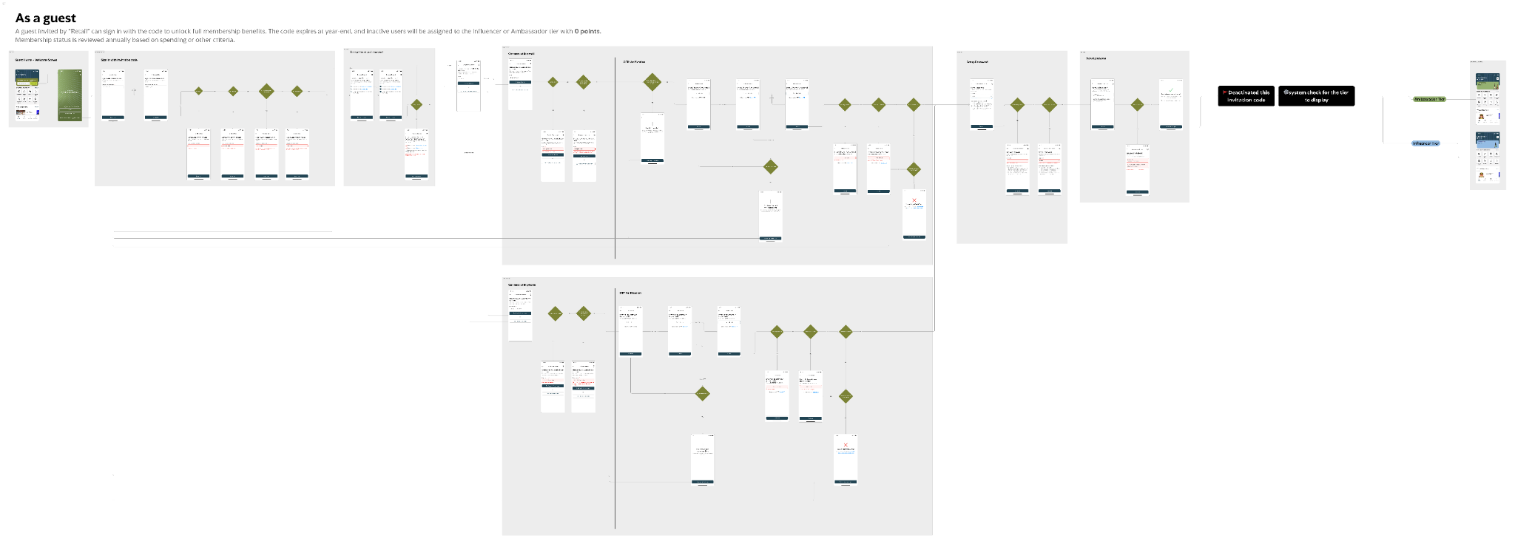
Full Access via Link: Figma

Disable Name Editing for Invited User
      - User Story: As a user who logs in via Invitation Code, I should not be able to edit my first name and last name.
      - Acceptance Criteria
- In Edit Profile > Edit Name
  - First Name = read-only
Last Name = read-only
  - Continue button disabled
- User can still edit:
  - ID Card / Passport No. (if not yet provided)
  - Address
  - Date of Birth
  - Gender
      - UXUI Design
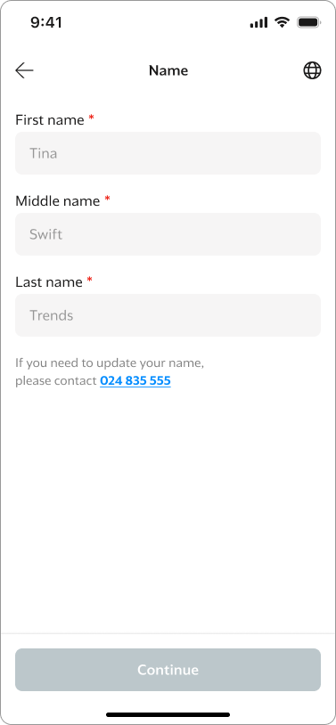

Generate Invitation Codes
      - User Story: As Retail BU, I want to generate Invitation Codes for a specific VIP list so that each VIP can access the application using a personalized code.
      - Acceptance Criteria
- Code is unique per individual
- Character set: A–Z, 0–9 (uppercase only)
- Length = 10 characters
- Code is non-transferable
- Code expires on last day of calendar year
- Code usable only once for activation
- Code configurable for Tier: Influencer, Ambassador
      - Stored Data
- VIP First Name
- VIP Last Name
- Validity Period
- Tier
- Status (Active / Deactivated / Expired)

Upgrade Membership

Upgrade Membership with Code
      - Narrative: As-is the upgrade membership feature accessed by users via embedded webviews.This task allows users to upgrade their retail membership tier using a special Upgrade Code provided by Retail BU via application directly.
      - User Story: As a user, I want to upgrade my retail tier using an upgrade code so that I can upgrade my retail tier with code received .
      - Acceptance Criteria
- Access
  - User opens My Profile
  - User taps “Upgrade Membership”
- Input Rules
  - Length = 10 characters
  - Character set: A–Z, 0–9
  - Auto-uppercase
  - Required field
- Success Behavior
  - Display success screen
  - Display upgraded tier
  - If user presses Back → input cleared
  - Using a new code overrides previous tier
- Error Handling
  - Empty or invalid code → display error
  - System error / timeout → display “Something went wrong”
- Tier Result
  - Tier assigned based on code configuration: Influencer, Ambassador
      - UXUI Design: Full Access via Link: Figma
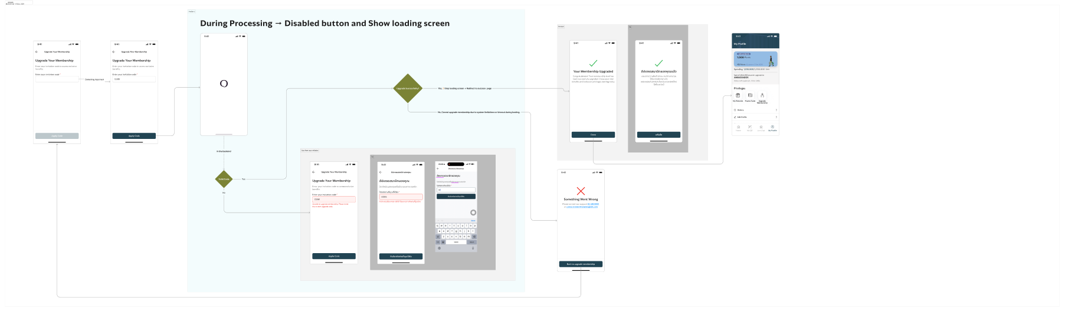

Generate Invitation Codes
      - User Story: As Retail BU, I want to generate Upgrade Membership Codes so that users can upgrade their tier based on code configuration..
      - Acceptance Criteria
- Code is uniquel
- Character set: A–Z, 0–9 (uppercase only)
- Length = 10 characters
- Code expires on last day of calendar year
- Code usable only once for tier upgrade
- Code configurable for Tier: Influencer, Ambassador
      - Stored Data
- Validity Period
- Tier
- Status (Active / Deactivated / Expired)

Data Flow

Invitation Code

Registration with invitation-code Flow
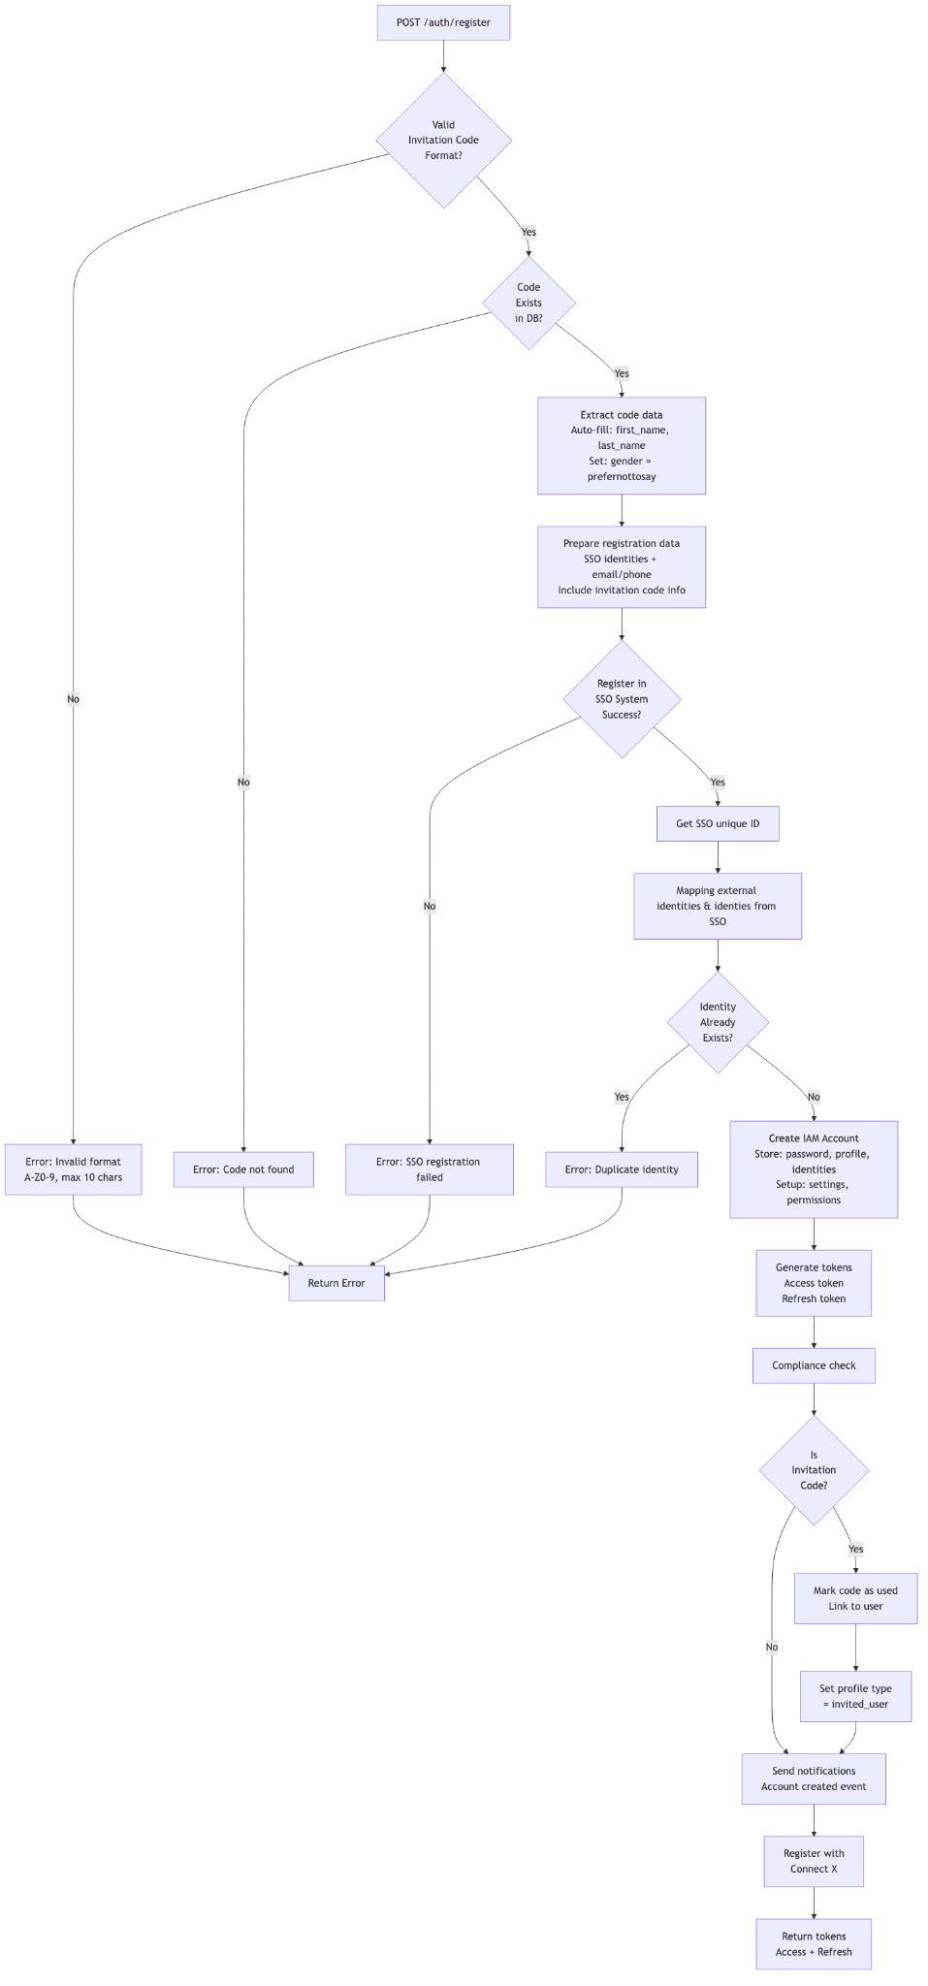

Table ER - Diagram
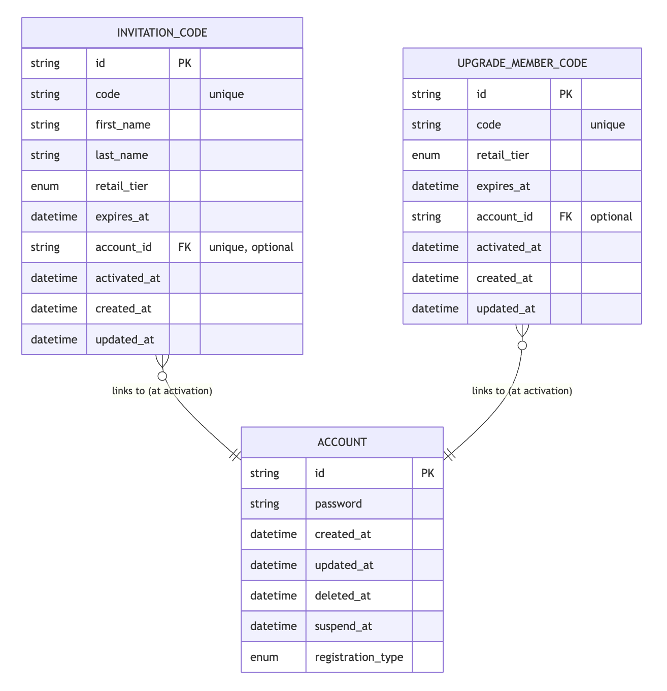

Generate Invitation Code Flow
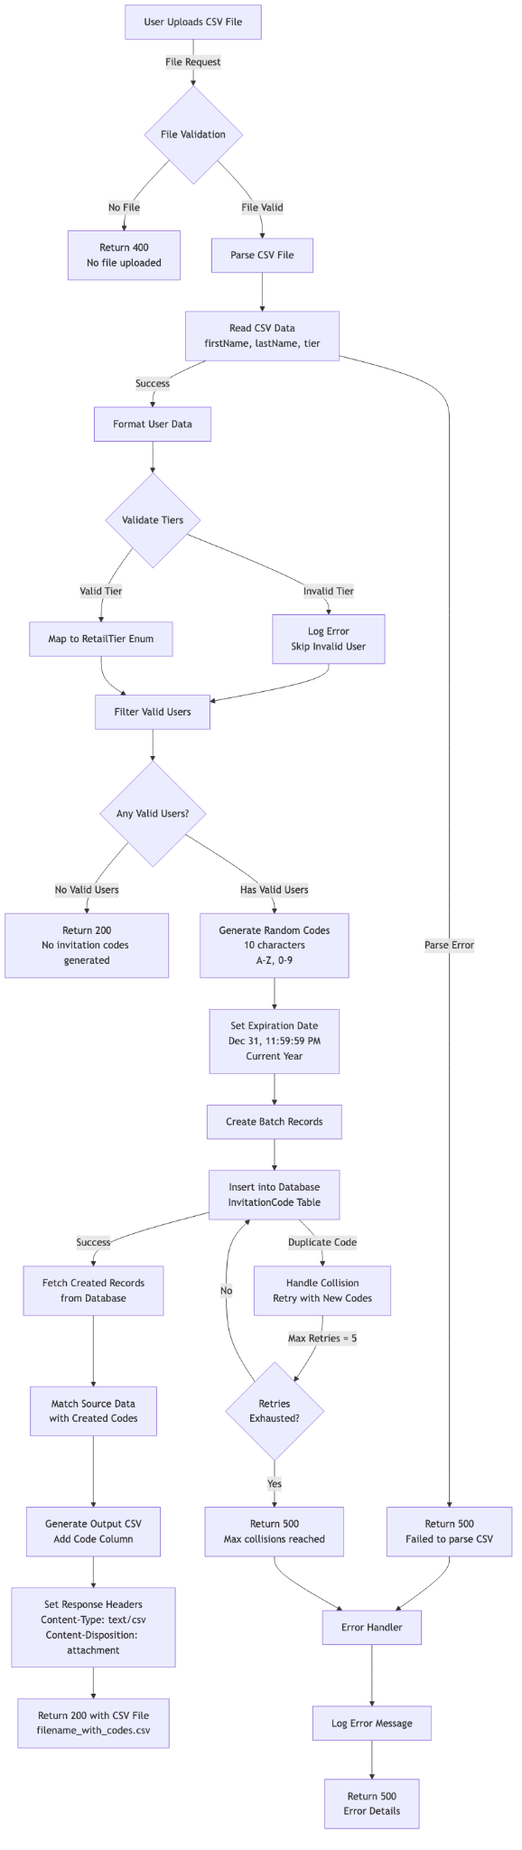

Upgrade Membership

Upgrade Membership Flow
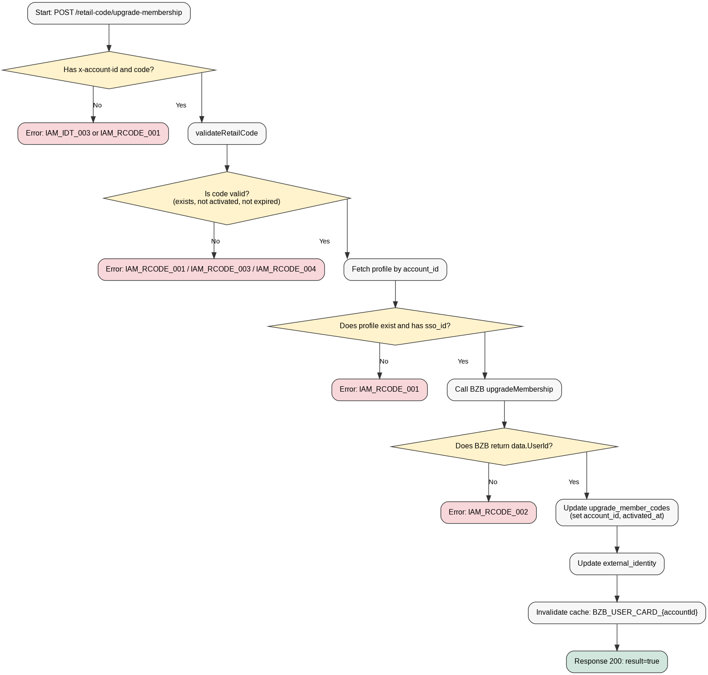

Generate Code Upgrade Flow

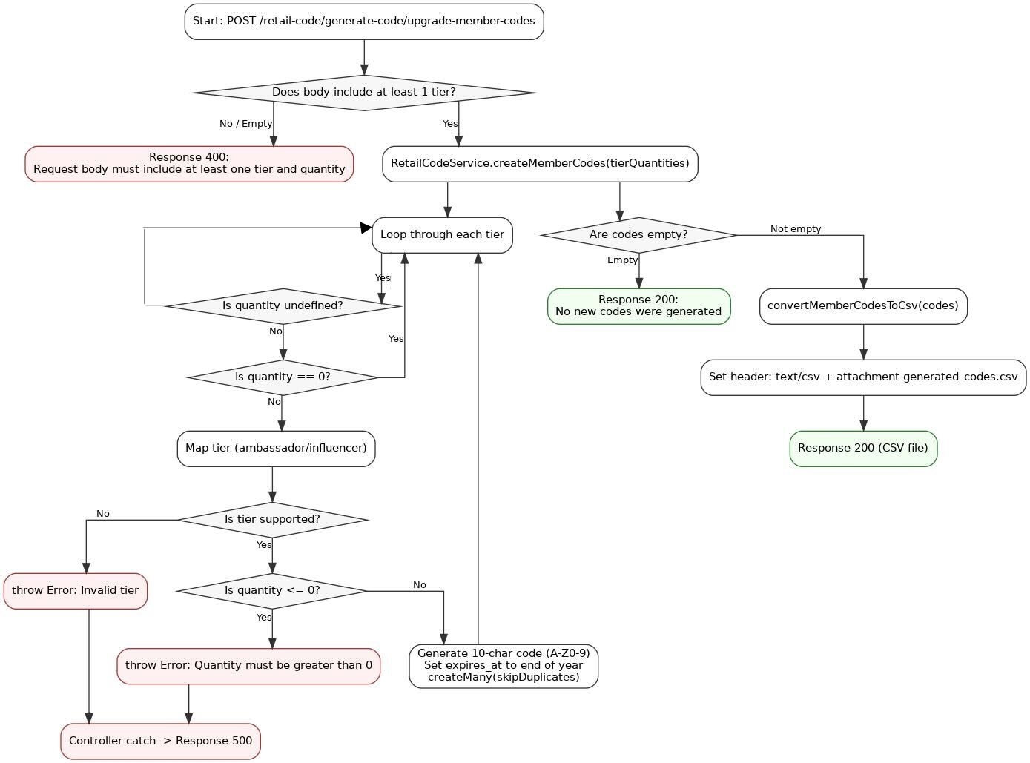

Example Request/Response

Request - Invitation Code Registration
POST {iam_base_url}/auth/register
Content-Type: application/json
app-version: 2.8.0
{
"registerMethod": "invitation-code",
"invitationCode": "ABC123XYZ9",
"profile": {
"dob": "1990-01-15",
"title": "mr"
},
"identities": {
"provider": "email",
"identifier": "user@example.com"
},
"password": "SecurePass123!",
"device": {
"device_id": "uuid-device-123",
"os": "iOS"
},
"push_token": {
"value": "fcm_token_abc123xyz",
"type": "fcm"
},
"sso_register": {
"emails": [
{
"value": "user@example.com",
"isDefault": true
}
],
"phoneNumbers": [
{
"value": "+66812345678",
"isDefault": true
}
],
"addresses": [],
"external": []
},
"receive_updates": true
}

Response (Success - 200)
"data": {
"token": {
"value": "eyJhbGciOiJIUzI1NiIsInR5cCI6IkpXVCJ9..."
},
"refreshToken": {
"value": "refresh_token_xyz789abc..."
}
}

Response (Error - 400 - Invalid Code Format)
{
"message": "Invalid request body",
"status": 400
}

Response (Error - 400 - Code Not Found)
{
"message": “Code not found",
"status": 404
}

Response (Error - 500 - Duplicate Identity)
{
"message": "Identity already exists",
"status": 500
}

Response (Error - 400 - SSO Registration Failed)
{
"message": "External SSO system registration failed",
"status": 400
}

Error Scenarios
Error | Status | Message | Cause
Invalid invitation code format | 400 | "Invalid request body" | Code contains lowercase, special chars, or wrong length
Invitation code not found | 400 | "Code not found" | Code doesn't exist in database
Code already activated | 400 | “Code already activated” | The invitation code already used
Code expired | 400 | “Code expired” | This invitation code already expired
Duplicate email/phone | 500 | "Identity already exists" | Email or phone already registered
Missing password | 500 | “Password cannot be null" | Password required but not provided
Invalid tier in code | 400 | "Invalid retail tier" | Code has invalid tier value
Database error | 500 | "Failed to create account" | Database operation failed

HTTP Status Codes
Code | Meaning | When Used
200 | Success | Account created, tokens returned
400 | Bad Request | Invalid code format, missing required fields
404 | Not Found | Invitation code not found
500 | Server Error | SSO error, database error, system failure

Request - Generate Invitation code
POST {iam_base_url}/retail-code/generate-code/invitation-codes
Content-Type: multipart/form-data

--boundary

Content-Disposition: form-data; name="file"; filename="users.csv"
Content-Type: text/csv
firstName,lastName,tier
John,Doe,influencer
Jane,Smith,influencer
Bob,Johnson,ambassador
--boundary–

Response (Success - 200)
FirstName,LastName,Tier,Code
John,Doe,influencer,A3X9K2L7M1
Jane,Smith,influencer,B5Y8N4P6Q9
Bob,Johnson,ambassador,C7W1J3R8T2

Response (Error - 500)
{
"message": "Failed to generate invitation codes: Failed to create invitation codes due to repeated collisions."
}

Error Scenarios
Error | Status | Message | Cause
No file uploaded | 400 | "No file uploaded" | Missing file in request
CSV parse error | 500 | "Failed to generate invitation codes: {error}" | Malformed CSV
No valid users | 200 | "No new invitation codes were generated" | All users have invalid tiers
Max collisions | 500 | "Failed to generate invitation codes: Failed to create invitation codes due to repeated collisions." | Code generation conflicts
Database error | 500 | "Failed to generate invitation codes: {error}" | Database operation failed

Request - Upgrade Membership
POST {iam_base_url}/retail-code/upgrade-membership
Content-Type: application/json
x-access-token: Bearer <JWT>
{
"code": "TESTCODEJA"
}

Response (Success - 200)
{
"data": {
"result": true,
"message": "Upgrade member code activated successfully"
}
}

Error Scenarios
Error Code | Message | Remark
IAM_RCODE_001 | Invalid Code, Cannot found profile, No SSO ID | Display Error Message
IAM_RCODE_003 | Code taken | Display Error Message
IAM_RCODE_004 | Code Expried | Display Error Message
IAM_RCODE_002 | Call BZB Fail | Display Something went wrong

Request - Generate Upgrade Membership code

POST {iam_base_url}/retail-code/generate-code/upgrade-member-codes
{
"ambassador": 100,
"influencer": 50
}

Response (Success)
code : Tier,Code
ambassador,TESTCODE12
influencer,TESTCODE34

- Return file .csv (`Content-Type: text/csv`)

Response (Error)
HTTP Status | Cause | Message | Relate Code
400 | Not sent request body or body empty | Request body must include at least one tier and quantity | src/controllers/retail_code_controller.ts:86
500 | Tier not support or fail quantity condition | - Invalid tier: insider  - Quantity for <tier> must be greater than 0 | - throw: src/services/retail_code_service/index.ts (createMemberCodes), catch and 500: src/controllers/retail_code_controller.ts:104

